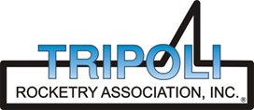
Tripoli Motor Testing Division
223 NC Highway 54 West
Chapel Hill, NC 27514
(919) 357 5681 (c)
January 10, 2023

Gary Rosenfield
RCS Rocket Motor Components, Inc.
2113 West 850 North Street
Cedar City, UT 84721

Dear Mr. Rosenfield,

The Aerotech O5500X-PS single-use reload kit (RMS) was tested on January 7, 2023 and complies with NFPA 1125. The motor is certified for hobby rocketry use by the members of the Tripoli Rocketry Association and all approving organizations with reciprocal certifying agreements.

Motor Manufacturer RCS Rocket Motor Components, Inc.
Manufacturer’s Designation O5500X-PS [single use - DMS]
Propellant Propellant X
TMT Nomenclature 21,384 O5515

Diameter 3.867” 98.45 mm
Overall Length 59.344” 1507.3 mm
Outside the MMT 2.438” 61.91 mm

Loaded Mass 37.00 lb 16,783 g
Propellant Mass 21.559 lb* 9779 g*
Burnout Mass 14.925 lb 6769.9 g
* = data provided by manufacturer

Burn time 4.026 sec

Total Impulse 4807 lbf.s 21,384 N.s
Max Impulse 1697.7 lbf 7551.5 N
Average Impulse 1239.7 lbf 5514.6 N
Number of Motors Tested 2

Nominal Measured
Delay Time Data n.a. n.a.

Casing Temp. [NFPA 1125 7.4.1] Passed

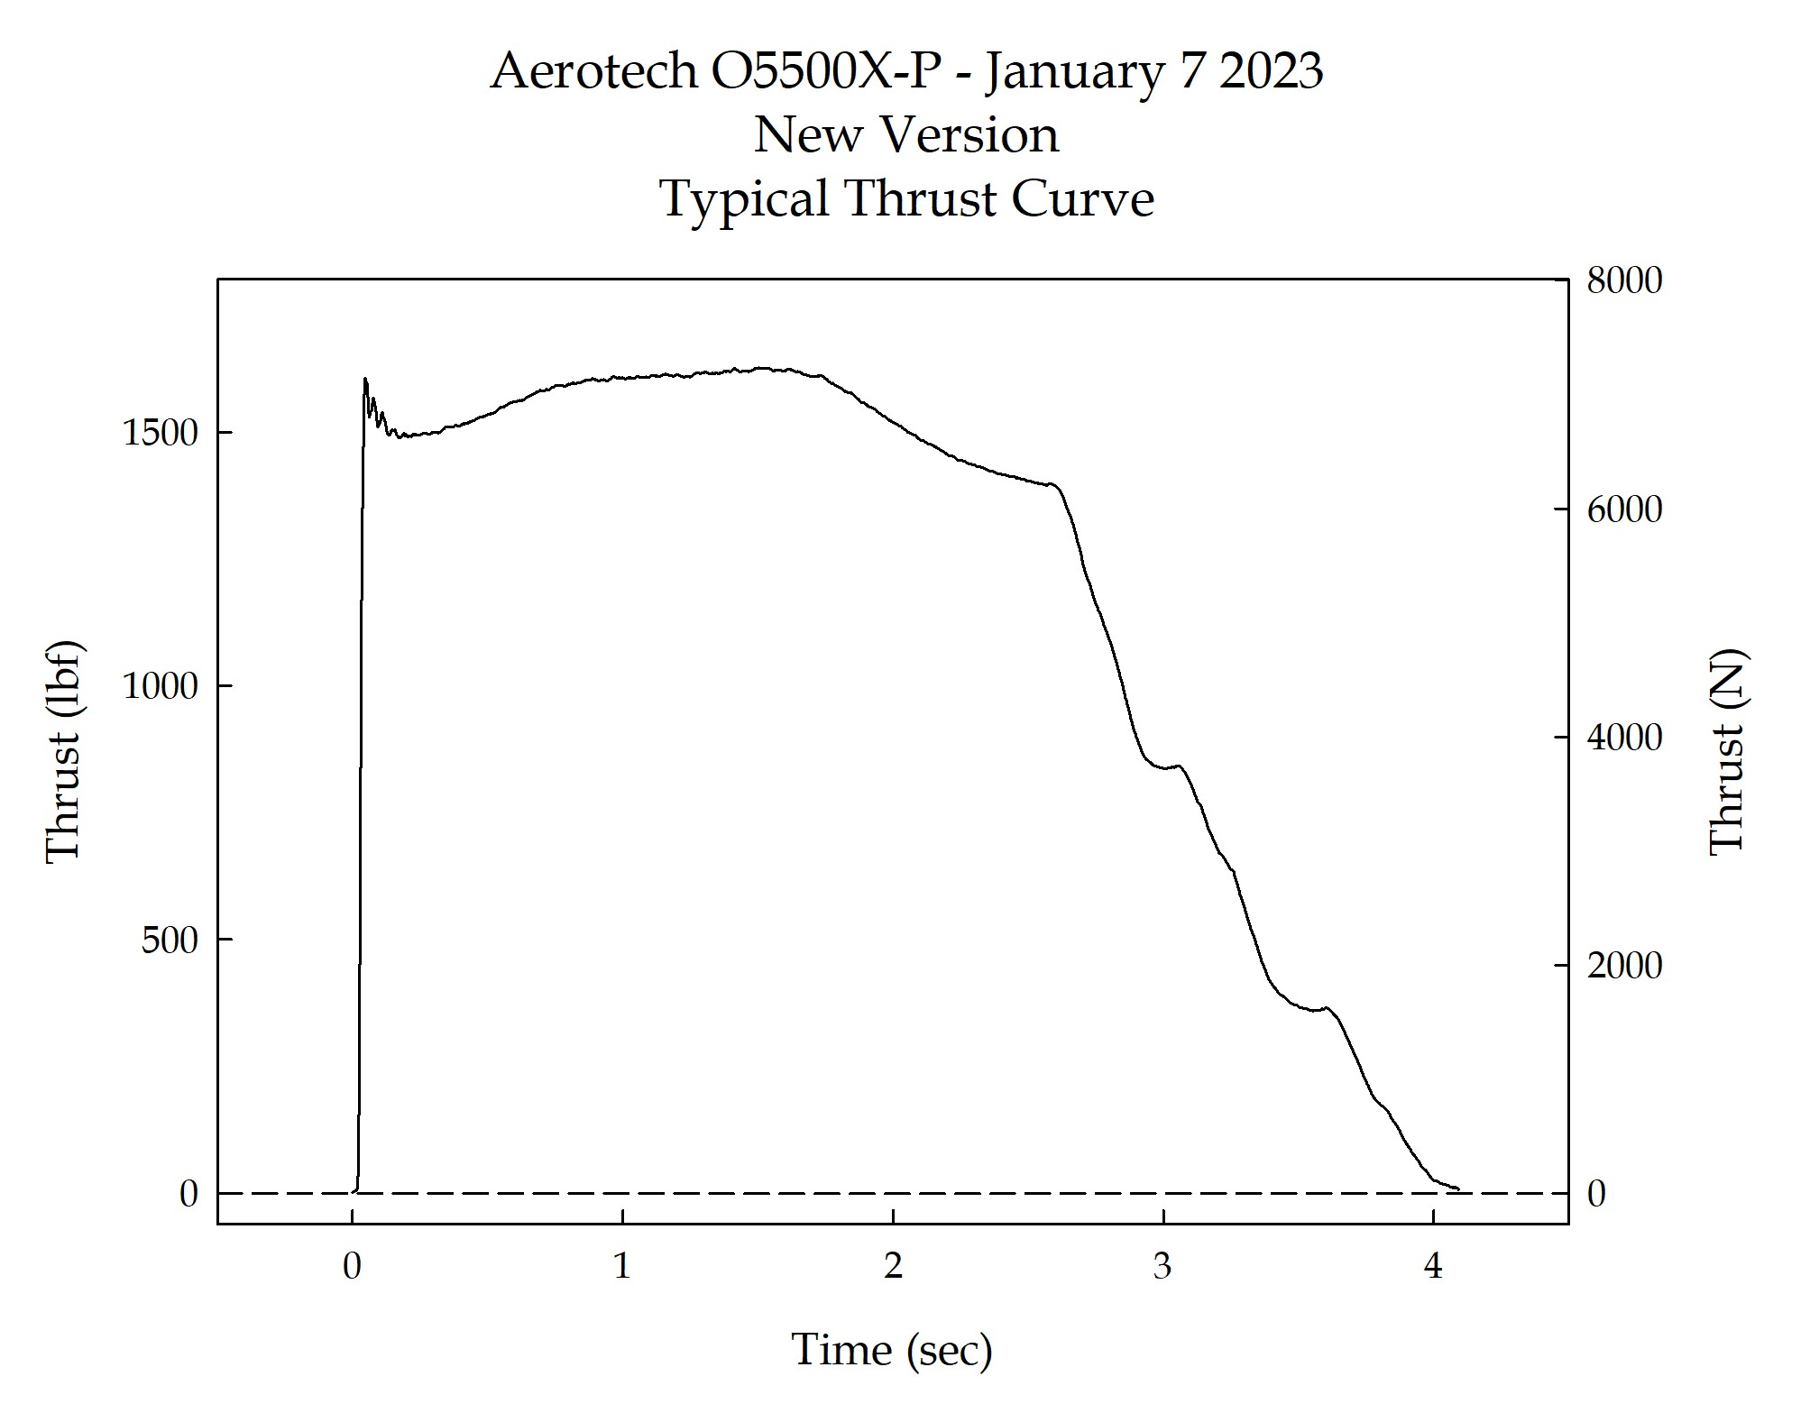

Sincerely,

Alan C. Whitmore
Chair, Tripoli Motor Testing

